**30 - R710 Proxmox - PiHole for homelab**

Setup PiHole for name resolution of vm’s in homelab:

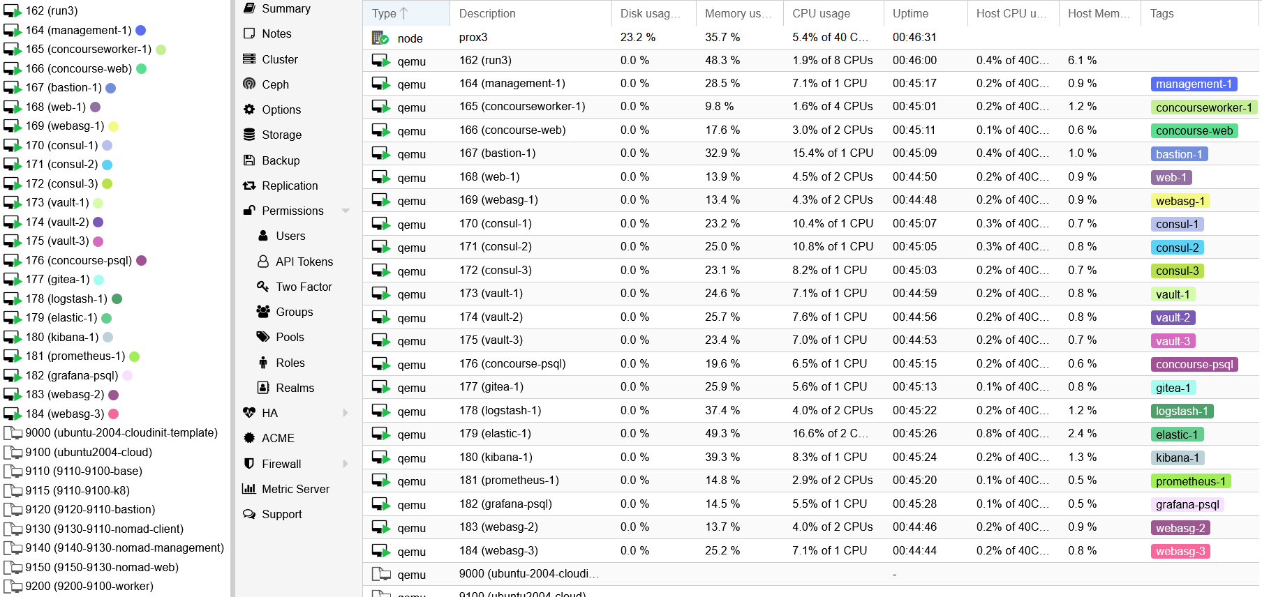

# 1. Configuring a Debian LXC Container for Pi-hole:

1. Configuring a Debian LXC Container:  
   Select storage location to store the container template, select CT Templates, then select Templates  
   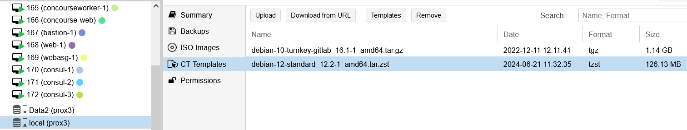
2. Search for **Debian**, then select **debian-12-standard** and **Download (already downloaded in above picture)**
3. After template has downloaded, select Create CT
4. Enter Hostname, CT ID and Password and click Next  
   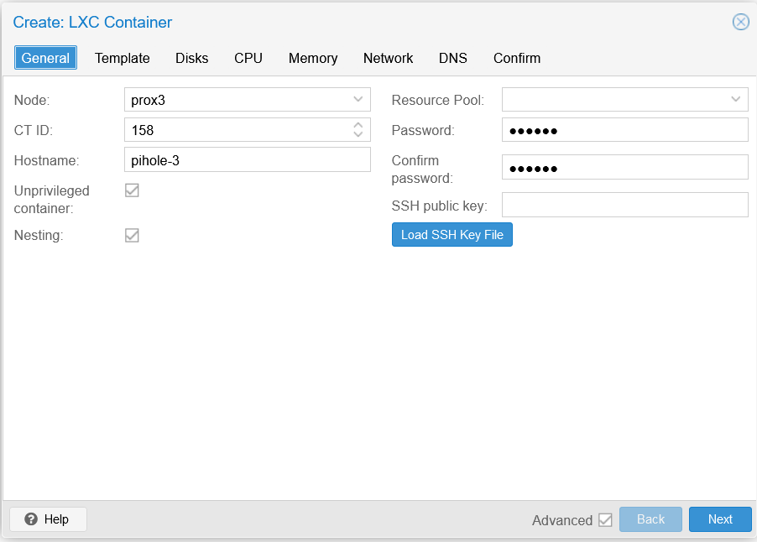
5. Select the Template just downloaded and click Next

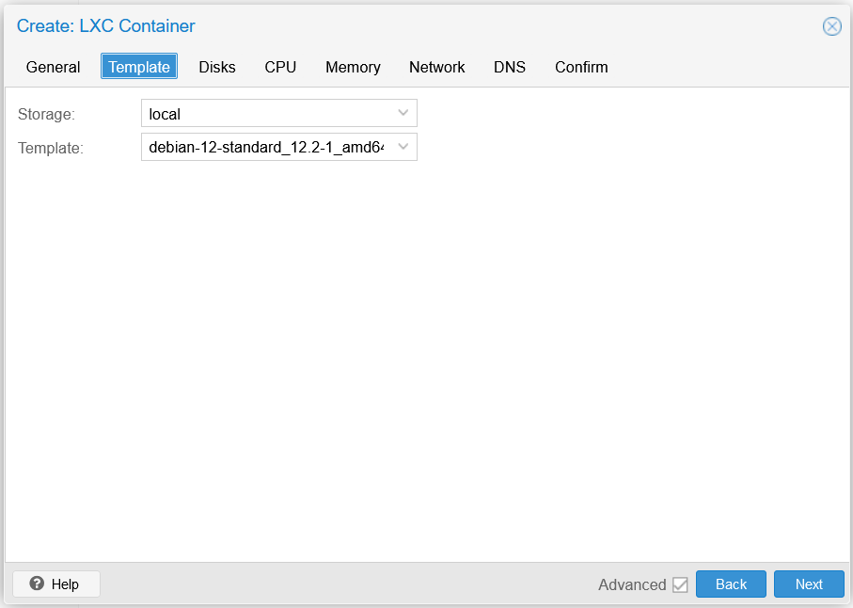

1. Adjust Storage placement and Disk Size as below and click Next  
   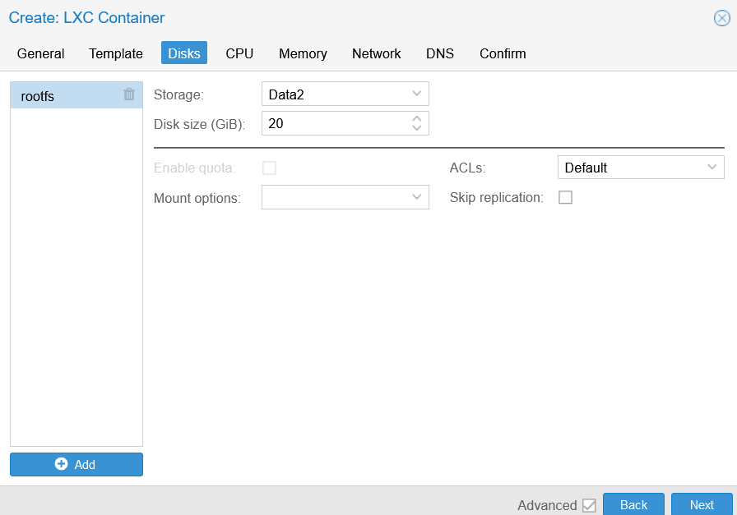
2. Adjust CPU details as below and click Next  
   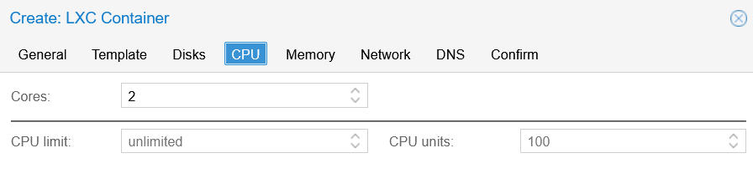
3. Adjust Memory details as below and click Next  
   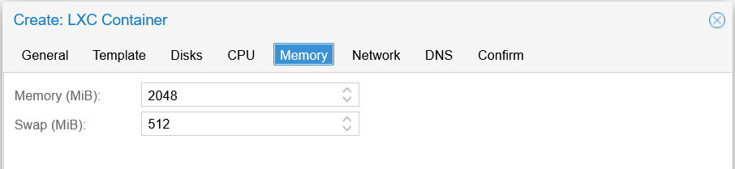
4. Adjust Network details as below and click Next  
   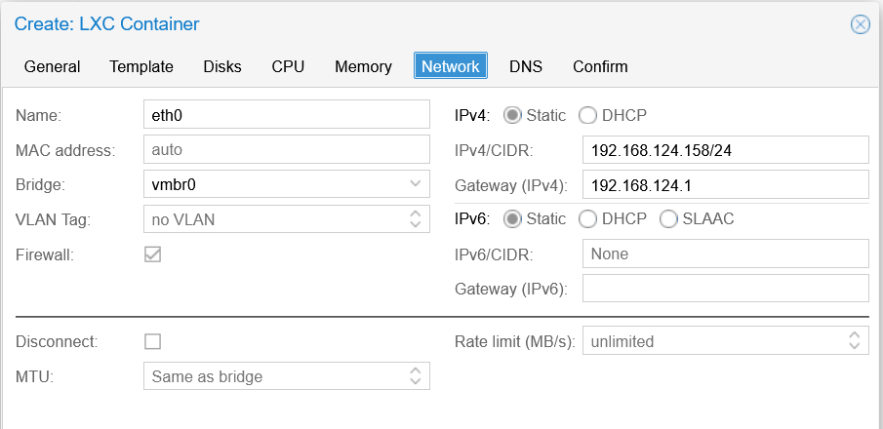
5. Adjust DNS details as below and click Next  
   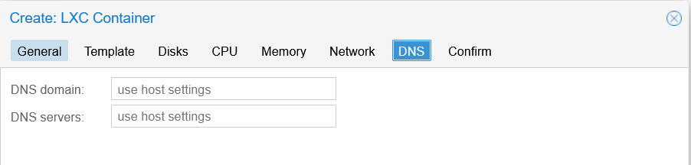
6. Confirm the settings as below and click Finish  
   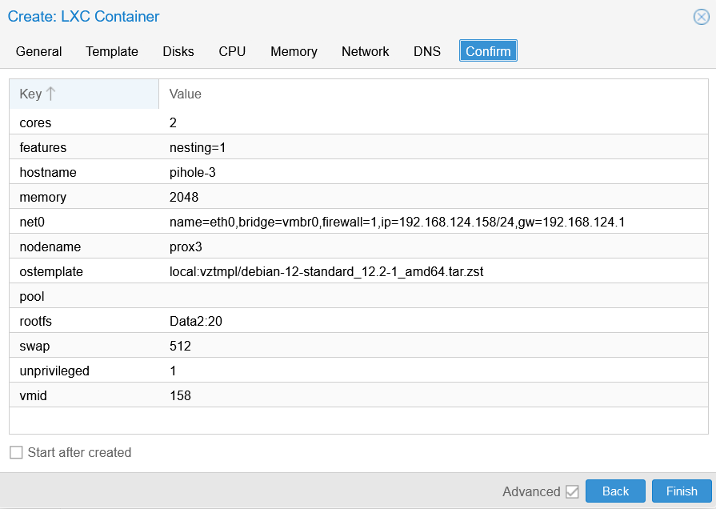
7. Adjust Start at boot and order as below:  
   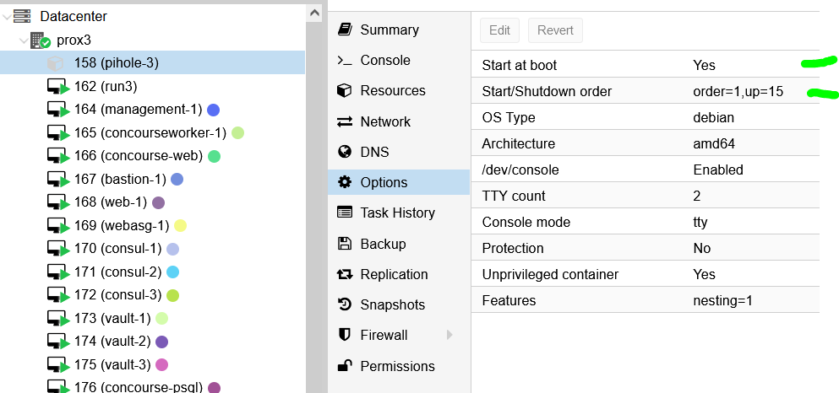
8. Start the container and once it is running, in the Proxmox Console log in as root with previously set password .. and update the system with:  
     
   **apt update && apt upgrade -y**
9. After the system has updated, install curl with:

**apt install curl -y**

1. Curl is used to run script that installs docker.
2. Enter:  
     
   **reboot**

# 2. Setting up and Configuring Pi-hole:

1. Following on from the previous step, run the following script:  
     
   **curl -sSL https://install.pi-hole.net | bash**

This will quickly appear and may also disappear quickly:

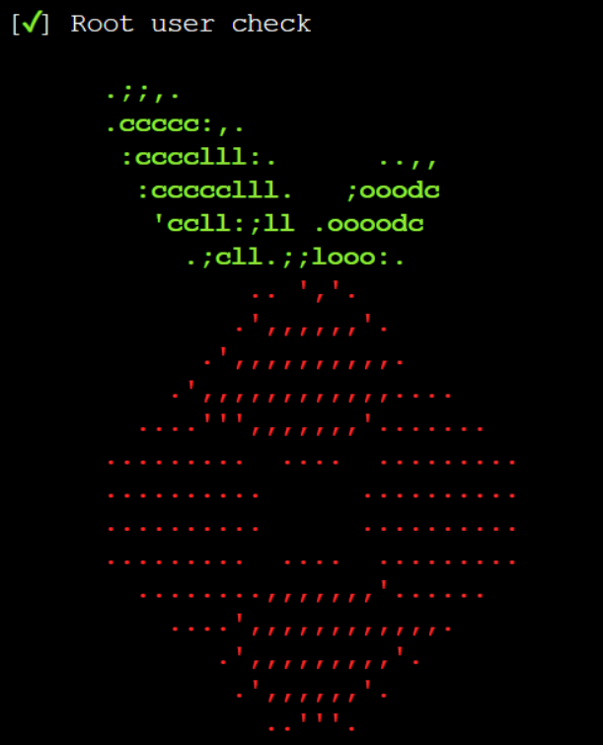

1. Press enter until you get to this screen:  
   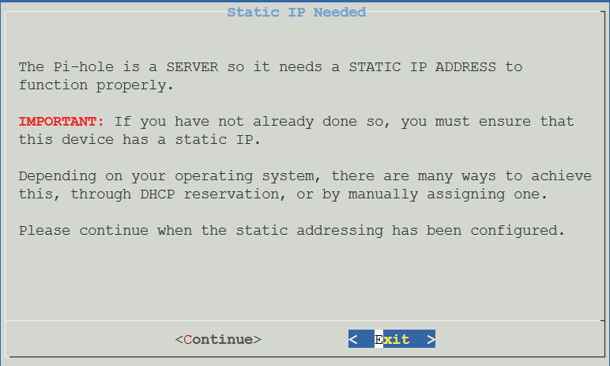
2. Press TAB to select continue and press Enter
3. On this screen, ensure ‘Google (ECS, DNSSEC) is selected and OK is selected and press Enter:  
   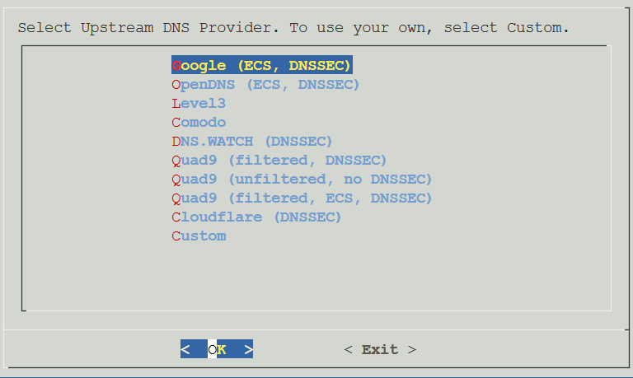
4. On the Blocklists screen, select Yes and press Enter:  
   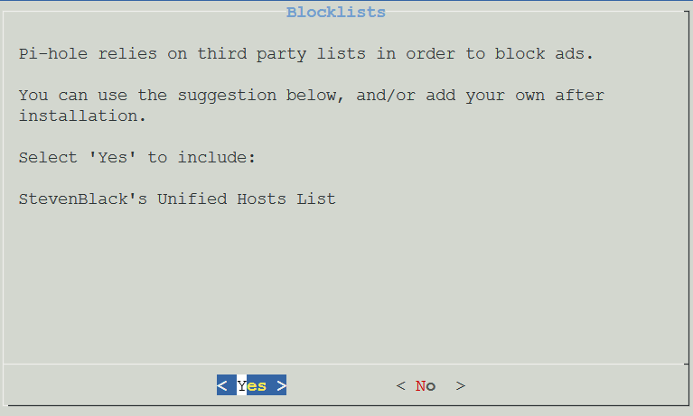
5. For Admin Web Interface, select Yes and press Enter:  
   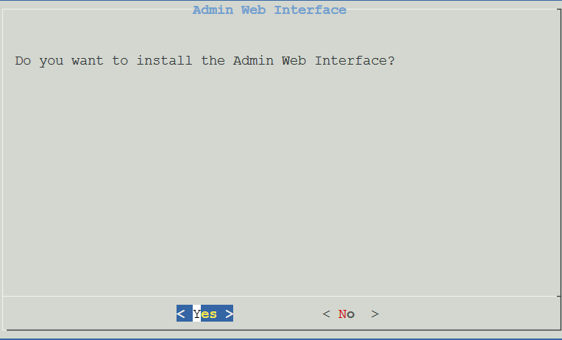
6. For the next screen, select Yes and press Enter:  
   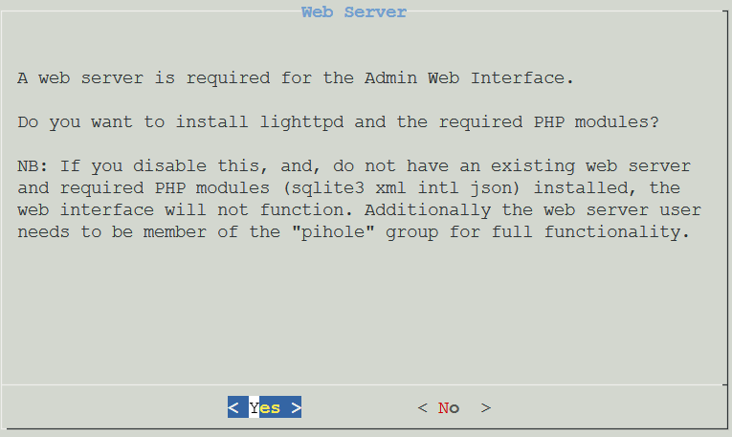
7. For the next screen, select Yes and press Enter:  
   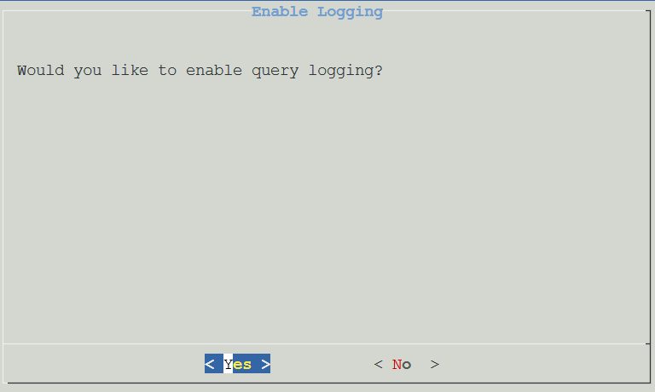
8. Select Show Everything, select Continue and press Enter  
   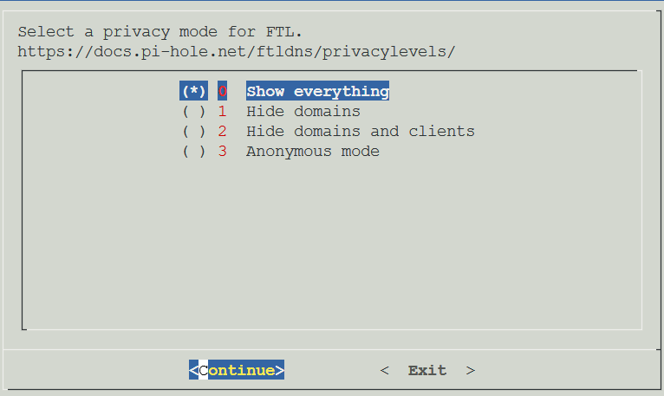
9. Pi-hole will now install itself and finish by showing:  
   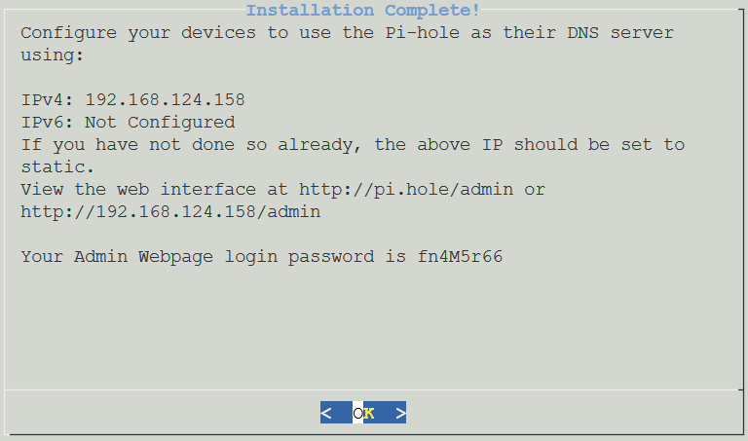
10. Connect to Pihole at its admin endpoint, with the above admin password:  
    <http://192.168.124.158/admin>
11. You will be presented with:  
    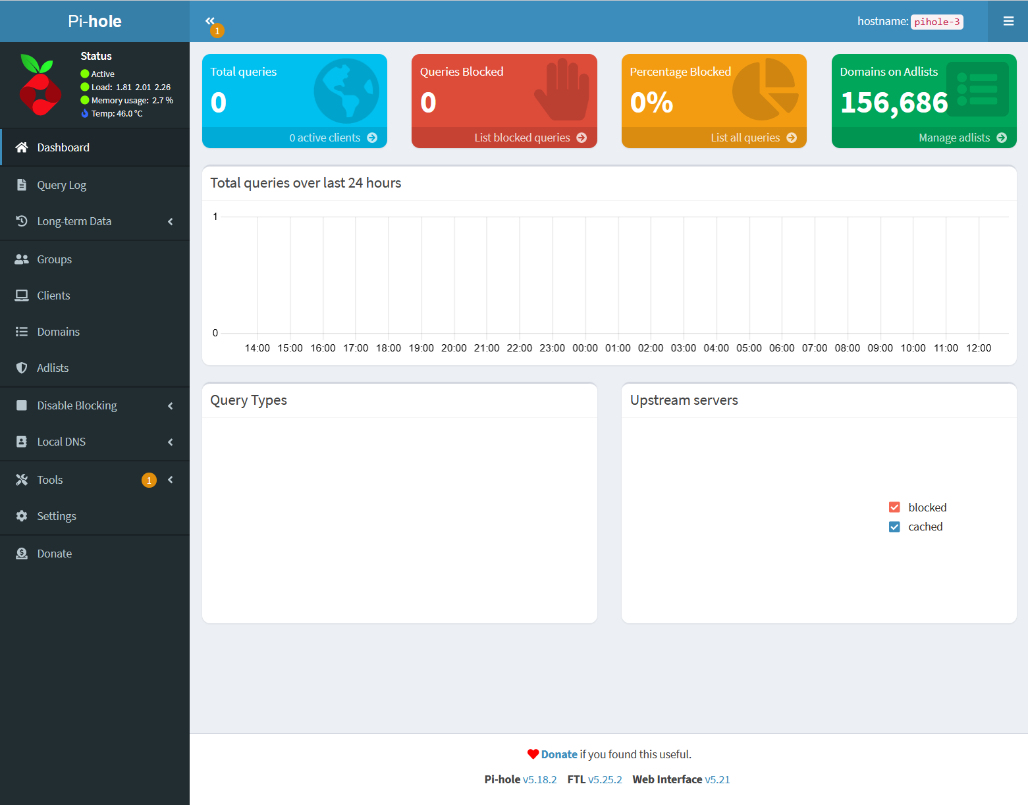
12. Logout of Pi-hole and log into the container console to change password, following these steps:  
      
    The Web interface password needs to be reset via the command line on your Pi-hole.

Use the pihole command to do this:

**pihole -a -p**

You will be prompted for the new password.

If you enter an empty password, the password requirement will be removed from the web interface.

1. That completes initial setup of Pi-hole.

# 3. Adding Local DNS Records for VM’s in Homelab:

1. In Pihole, go to this screen ‘Local DNS’:  
   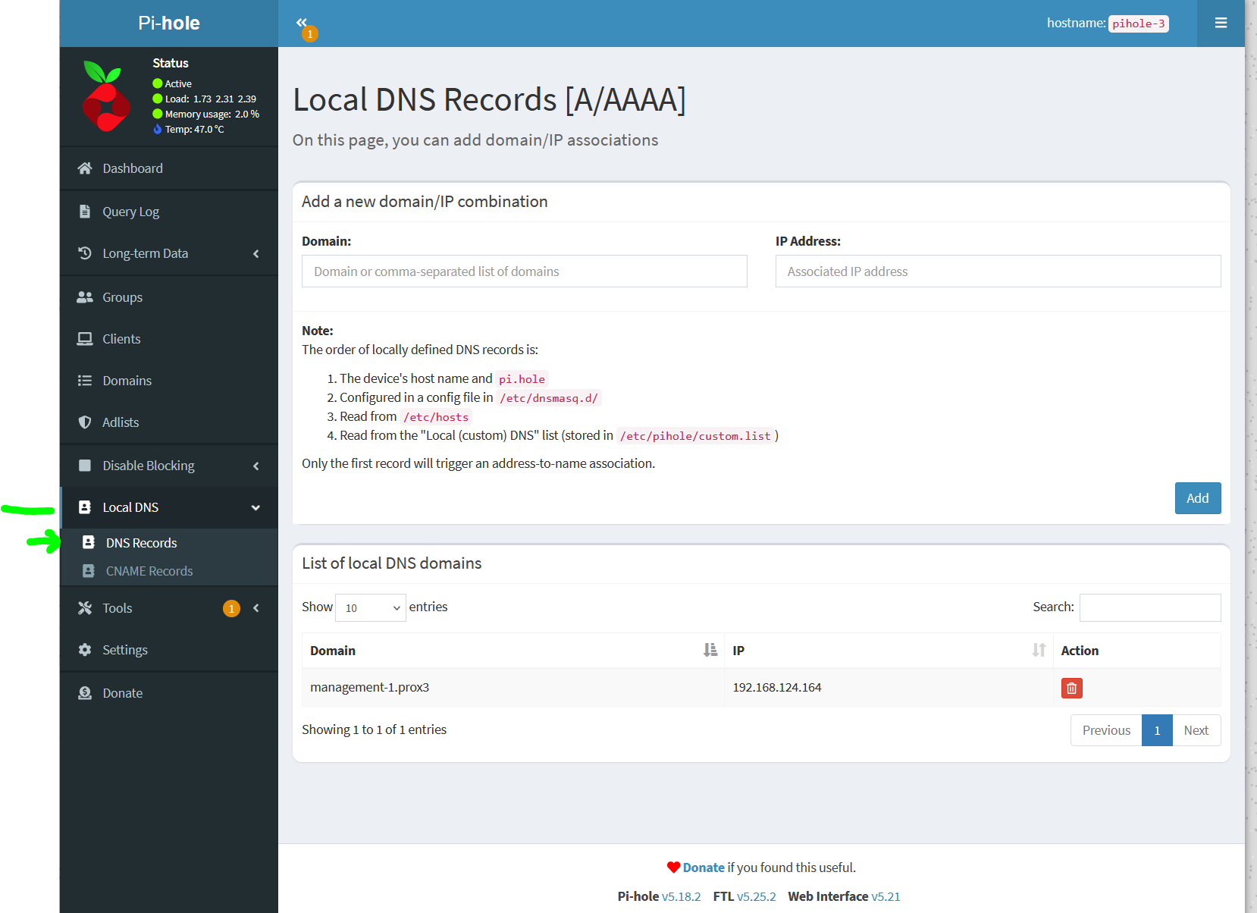
2. In the top section ‘Add a new domain/IP combination’ enter a homelab VM Domain name and Ip Address as per the one set up as seen in the lower section ‘List of local DNS domains.
3. Repeat for all required VM’s.
4. To test a VM can see / use Pi-hole, change its **/etc/netplan/50-cloud-init.yaml** file such that its **nameservers** section is as below (you’ll need to be root for this):  
     
   network:

version: 2

ethernets:

eth0:

addresses:

- 192.168.124.180/24

gateway4: 192.168.124.1

match:

macaddress: 22:5a:f8:b3:f5:f5

nameservers:

addresses:

**- 192.168.124.158**

set-name: eth0

1. Save the change and reboot the VM
2. Log back into the changed VM and if all is well, the following should work:  
     
   ping management-1.prox3
3. Apply the above nameservers change to **/etc/netplan/50-cloud-init.yaml** in all needed VM’s
4. Once all VM’s are updated, remove any old hostnames from /etc/hosts file for the VM’s whose **/etc/netplan/50-cloud-init.yaml** file has been changed.
5. For all VM’s in proxmox, in Options adjust their start order such that pihole-3 is order 1 with up 15, run3 is order 2 with up 30 and others have their order bumped by one … and adjust any other homelab setup files with this new information.
6. Adjust run3 host to use Pi-hole as a secondary DNS and if ok, clean up its hosts file and update any document for run3 host.
7. That’s all.